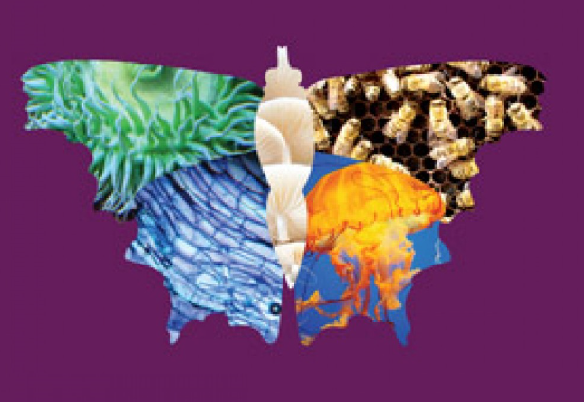
MSEE Junior Level Life Science
2018-19 with Ms. Tish
It’s Alive! What does that mean, and what does it take for living things to survive? How many living things share planet Earth with us? How do they all work together? We’ll explore these questions and many more as we dive, fly, walk, run and crawl through life science!

Oct | Nov | Dec | Jan | Feb | March | April | May
The Nature of Science– Introduction to Life Science | Diversity and Evolution of Living Organisms |  | Organization, Development & Reproduction of Living Organisms |  | Interdependence |  | Making Science Connections – Studying Living things in the World
10/3 – Is it alive? What is a living thing and how do we know? | 11/7 – Animal Diversity – the furry, scaly, feathery and more | 12/5 - Neither Plant nor animal? Fascinating Fungus | 1/2 - Up Close and Personal – What’s in a cell? | 2/6 – Life is Complicated! Living Systems Part II – Eating, Breathing and Dealing with the “leftovers” | 3/6 –Survival 101 – Living things and the resources they need | 4/3 – it’s all about “NRG” - from the sun to the cell!  . | 5/1 - Changes over time – the world of fossilized life
10/17 – Animal, Vegetable or Neither? The science of Classification | 11/21 – Plant Diversity – mosses, trees, flowers and more | 12/19 – Tiny Worlds of Life – Single-Celled Living things | 1/16 - The Work of Life – Living Systems – Standing up, Sensing and Moving Around | 2/20 - Carrying it forward – DNA and Life Cycles | 3/20 - What are they doing? The Science of Behavior | 4/17 – What’s your Niche? Living things and the places they live. | 5/15 – Where do we fit in? Humans in the ecosystem

