Oct | Nov | Dec | Jan | Feb | March | April | May
The Nature of Science– Introduction to Life Science | Organization & Development of Living Organisms | Heredity & Reproduction |  | Diversity and Evolution of Living Organisms |  |  | Interdependence
10/3 – What is Science? Misconceptions and the scientific process. | 11/7 – What does it mean to be alive? Animal cells. | 12/5 - DNA, genes and chromosomes | 1/2 - Genetic mutation and variation | 2/6 – Speciation | 3/6 –Animal classification: We’re all tubes | 4/3 – Comparative anatomy & physiology | 5/1 - Ecosystem Dynamics
10/17 – What makes life possible on Earth? H₂O is only half the story. | 11/21 – Plant cells and photosynthesis | 12/19 – Reproduction on a cellular level | 1/16 - Adaptation and natural selection | 2/20 - Fossils and Homologus Scructures | 3/20 - Comparative anatomy & physiology | 4/17 – Animal behavior | 5/15 – Humans’ role in the ecosystem
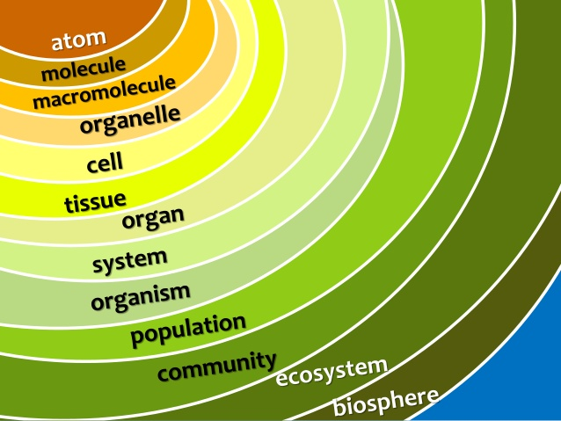
Hierarchy of Life
MSEE Senior Level Life Science 2018-2019
Life is complicated, messy, extraordinary, and beautiful. Over the course of 16 weeks, we will traverse the hierarchy of life to discover the similarities and difference among living things, and how those characteristics shape the biosphere of our planet.

